**Code Modification Lines:**

**#1)** Open the Box URL to run the Checkers Game  
- cd CheckersFinal-master  
- ls  
- python Checkers_v24.py

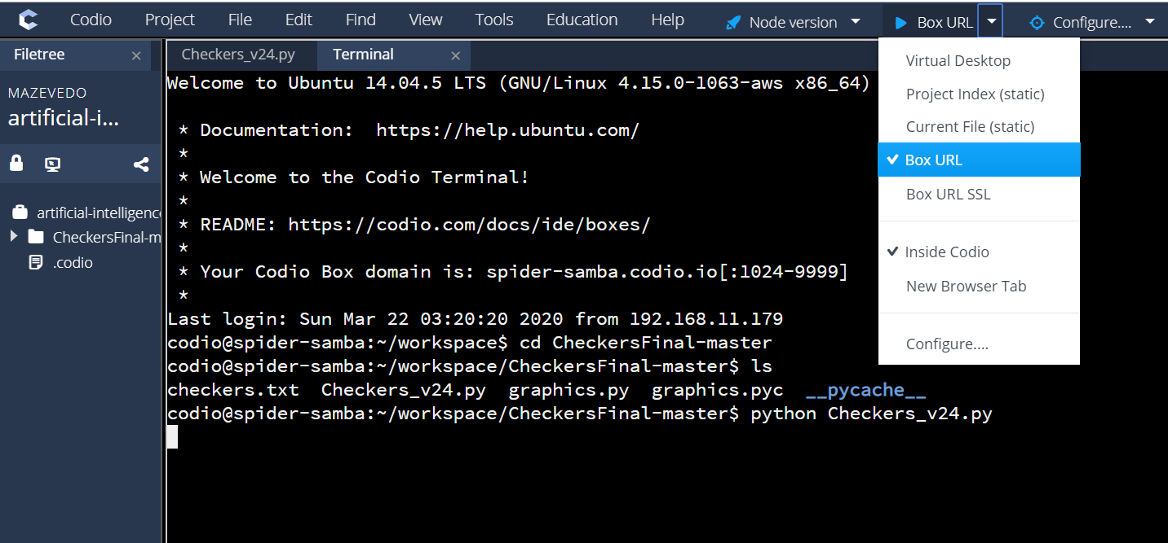

**#2)** Changed the ‘Standard’ button color (line 281) and for the ‘Clear’ button color (line 288). Changed the button color coordinates and text coordinates for the Start Button.

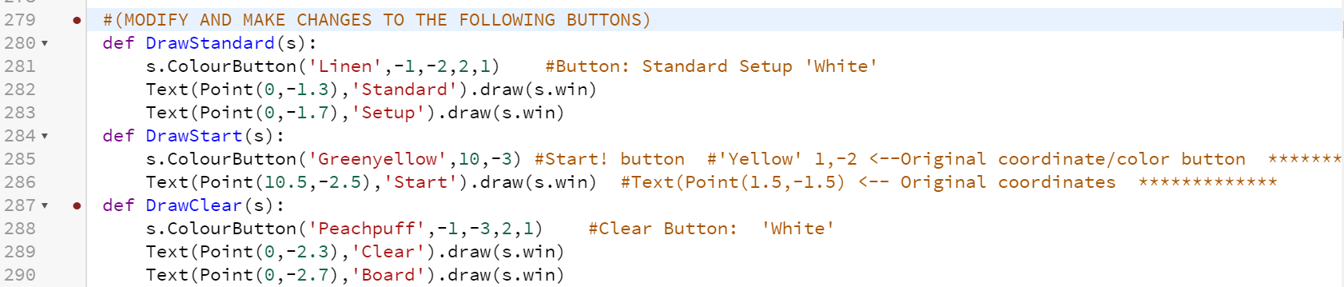

**#3)** Rearranged the coordinates for the ‘Load’, ‘Save’, and ‘X’ button. This section includes the Button color coordinates and Text coordinates. Changes the ‘Text’ location along with the ‘Button’ color location.

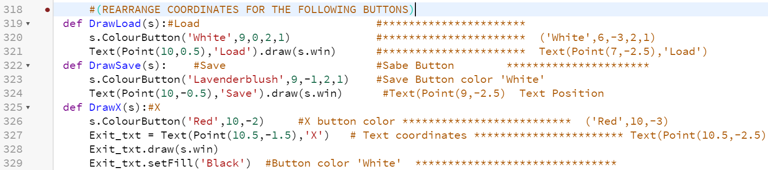

**#4)** This changes the ‘Delete’ and ‘Resign’ button ‘Colors’ and ‘Text’ coordinates.

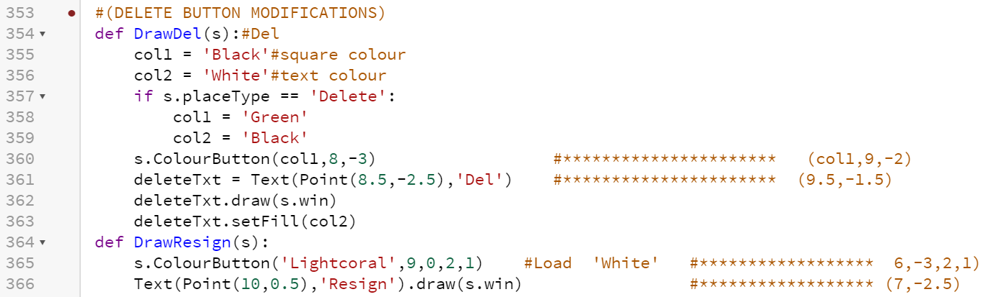

**#5)** This changes the ‘X’ and ‘Start’ mouse click coordinates

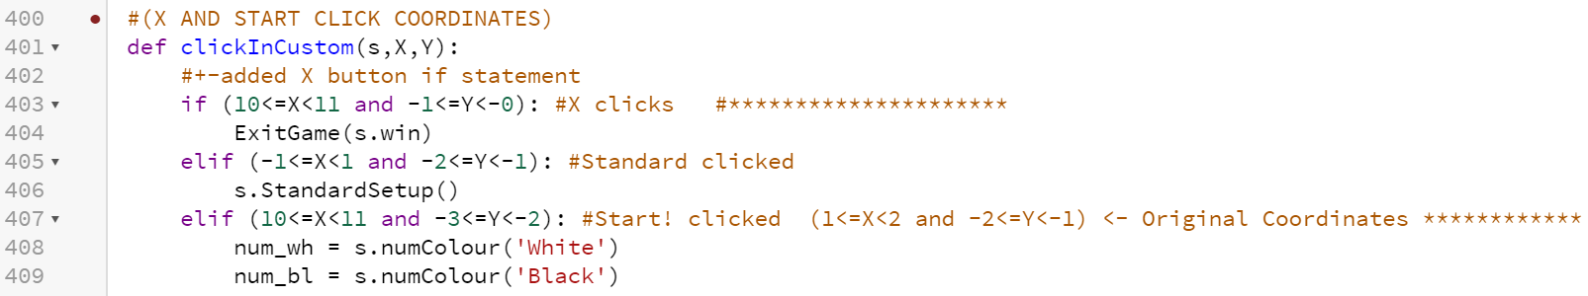

**#6)** Change the mouse ‘Click’ coordinates for the following Buttons (Save, Load, & Delete).

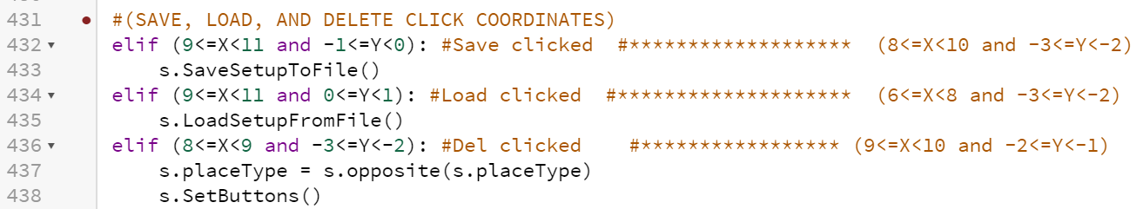

**#7)** This changes the ‘X’, ‘Save’, and ‘Resign’ clicks. The ‘X’ coordinates have to be similar to line 403. When the games Starts, only these 3 buttons become visible. Same thing for the Save button (line 432 & line 472). The Load button becomes the Resign button (line 434 & 474). The coordinates between both buttons have to be similar.

